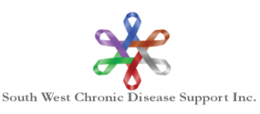
SOUTHWEST CHRONIC DISEASE SUPPORT INC

POLICY

Approved by: Board of Directors Policy No: 4-4

June 2023

Income Test Guidelines

General
- The applicant must provide a copy of the most recent Income Tax form showing line 15000 – Gross Income. If they are married the spousal gross income must also be shown. If the client is under the age of 18, the income of the parents or guardians will be used for the subsidy application.

- The following will be the qualifying gross income:
Individual, single with no dependents $120,000
Married, no dependents $150,000
Married, one dependent $155,000
Married, two dependents $160,000
- If there are three or more dependents the gross income will be raised $5000 for each additional dependent.
- The Application Committee will review each application and have the final decision as to whether the applicant qualifies.
- The applicant and spouse must read and understand the financial declaration and sign it prior to submission.
- In situations of financial hardship, the applicant will be asked to provide sufficient, additional information for the committee to decide if the guidelines can be amended in their situation.

